LANGCHAIN COMPONENTS

MODELS: this is the mst imp component of the langchain with the help of model interface
we can interact with the AI models
There are teo types of models in the langchain
1 language models like chatbots who take txt as an input and provide a txt as a output
2 Embdding models text as an input and give vector as a output these models are used in semantic search
Major application of langchain is the chatbot

LLMS are trained on the huge internet data thats why their sie is increased and its become a challange to run on their on hardwares the solution is used to API keys companies kep the llm on their servers and use the api keys around it than the user come give his query to api keys they send query to the llms llms understand the query and then return the output to the api keys and than api to the user so this problem also solved.

But Langchain identify a problem that the api of claud and geminie are different but if i want to use both apis in the same application than it become a challange because we need to change the code completley and both apis output response also different so the langchain introduce a interface that can talk to every company api keys you dont need to write a code again but do just a little change
so MODEL is the interface through which we can communicate with any company model

3 CHAINS :
in the langchain chainscomponent is very important in the langchain applications are able to build in the formof pipeline we just need to enter a n input and call the chain and we get output we dont need to callevery llm or any other thing in the langchain

Sequence CHAINS:
PARALLEL CHAINS:
Conditional chains:
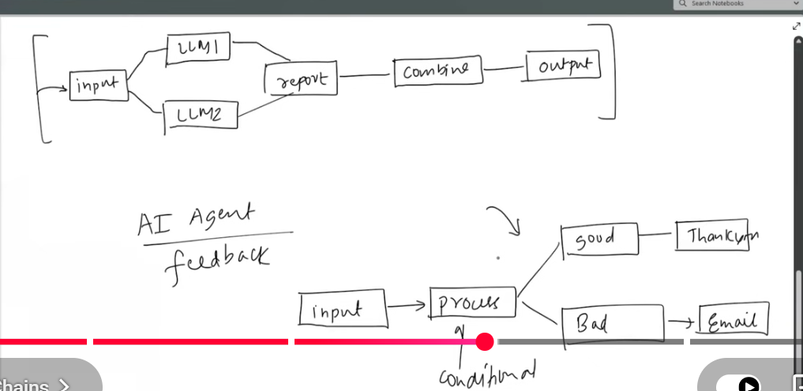
4 INDEXES:
AS we konw the chatgpt is also a llms model when we ask gpt about oue personal life q.s than gpt dont ans because the gpt is trained on the internet data not on our personal data so gpt is unable to ans so to overcome this problem langchain introduce the indexes componnet who help to guive our personal knowlwdge to gpt and than as q.s to the gpt
it includes DOC LOADER TEXT SPLITTING VECTOR STORE RETRIEVER

5 MEMORY: llm api calls are independent means the next call is independent form the previous calls means no memory stored
MEMORIES:
AI AGENTS:chatbots just ans the query but agents just not give an ans but also perform some task

